**Date:** 30/9/2024 20:00 to 21:00

**Attendance:** Phát, Đức, Huy

Phát, Đức re-evaluate the current ideas of the database

modify database according to the new erd

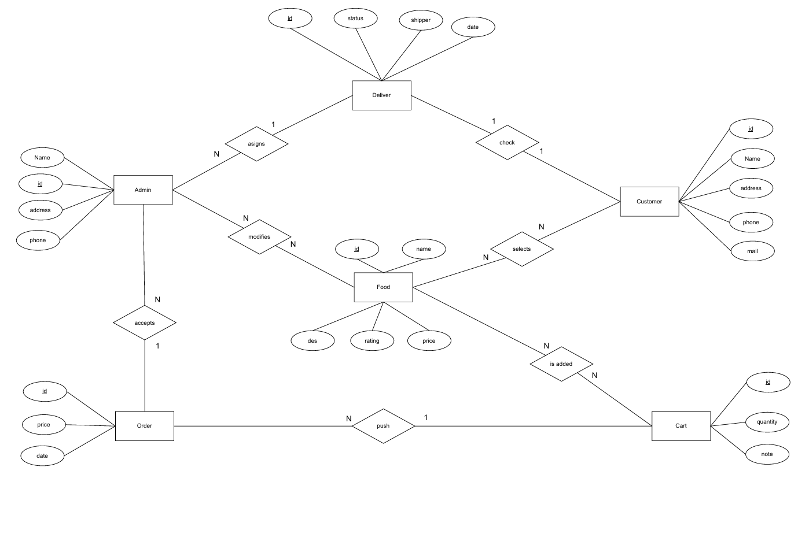

plan on what to have for UI, Huy investigate the UI template then give task for others

template sample: